**Dermatology Associates of Coastal Carolina**

**2115 Neuse Blvd. New Bern, NC 28560 (252)633-4461**

**Mohs Micrographic Surgery Picture Sheet**

**Patient Name**: LAST, FIRST MI.

**DOB**: 12/21/1931

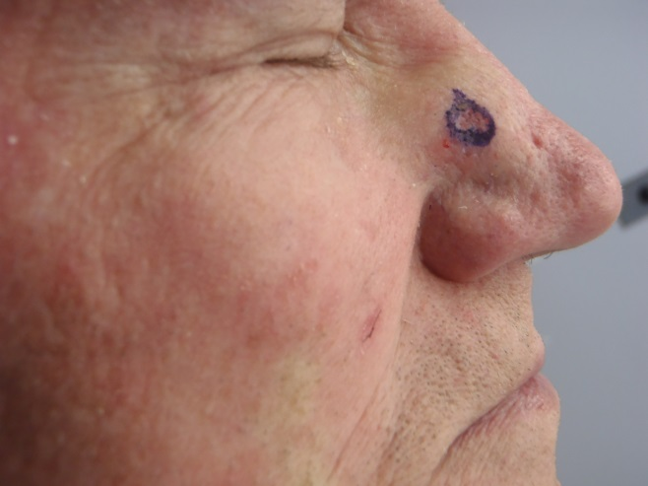**Accession #**: DA13-11209-A

**Mohs Case #:** 14-M-0015

**Date of Service**: 02/03/2014

**Tumor Type**: SCC

**Stages to Clear**: 1

**Surgeon:**  James M. Polo, M.D.

Pre-operative Photo:

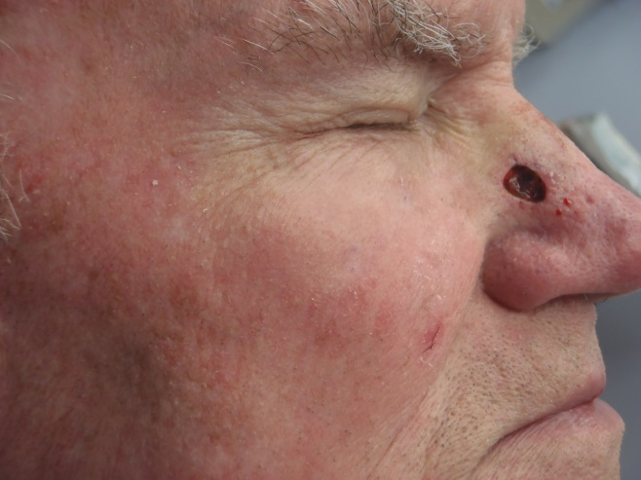

Post-operative Photo:

Closure Photo:

